

**TABLE OF FIGURES**

Figure 1. “world-data2023.csv” dataset 3

Figure 2. Errors in the raw dataset 4

Figure 3. selected data for analysis 5

Figure 4 . Horizontal bar chart measuring Average life expectancy per global region. 6

Figure 5. Horizontal bar chart comparing life expectancies of two regions in North America. 7

Figure 6. Horizontal bar chart showing Average population Density per Global Region 7

Figure 7. Minimum wage vs Life Expectancy scatter graph 8

Figure 8. Clustered bar chart showing a close up of minimum wage vs life expectancy 9

Figure 9. A clustered chart showing the 3 global metrics analysed thus far. 10

Figure 10. Bar chart showing Average GDP per Global Region. 10

Figure 11. Bar chart showing Average GDP per region (zooming in on top 10 countries) 11

Figure 12. Scatter graph showing relationship between birth rate and population density 12

Figure 13. Finding outliers 13

Figure 14. Outliers identified 13

Figure 15. Scatter graph which shows relationship between Gross tertiary eduacation enrolment vs Birth Rate 14

Figure 16. Bar chart showing the average birth rates of each global region. 15

Figure 17. Pie chart showing the average gross tertiary enrolment for each region. 15

Figure 18. Stacked column chart showing Average agricultural land vs Forested area. 17

Figure 19. 3D clustered bar chat 18

Figure 20. horizontal bar chart which shows the average land areas of different regions. 19

Figure 21. Zooming into “Russia” which has the highest land area, by measuring land distribution between Forested area and Agricultural land. 20

Figure 22. Scatter graph showing the correlation between physicians per thousand and life expectancy. 21

Figure 23 22

Figure 24. summary statistics of the two columns selected. 23

Figure 25. Testing Analysis summary output 23

Figure 26. Regression analysis model 24

The exploration of global metrics in the realm of international policy making guided by the world-data2023.csv dataset, allows us to delve into more than just statistical landscapes and numbers. This analysis will unravel intricate stories of economies, demographics, and societies across the globe where every data point is a guidepost which will steer us through the intersections between policy making and the dynamic essence of humanity.

The “world-data2023.csv” dataset has a range of different global metrics or variables as the columns. One unique identifier for all the observations is the column labelled Country. This is because each Country or Nation is connected to or affected by the various measurements that are used to assess its performance on a global scale. Some of the variables in this dataset include **economic indicators** such as (GDP, Minimum wage, Out of pocket health expenditure, Armed forces, CPI (consumer Price index) and CPI change, Tax rate, etc), **demographic statistics** namely ( population, population density, life expectancy), **Human Development Index** (comprised of the variables, infant mortality, Birth and fertility rate, Gross primary and tertiary education enrolment), **sociocultural metrics** (Official Language), and **environmental factors** ( CO2 emissions). From the ones listed, key metrics to be analysed within this report are GDP (Gross Domestic Product), population density, life expectancy, and minimum wage. A combination of these metrics contributes to the overall appeal of a country at a global scale in terms of attracting potential immigrants at the international level and guides policy-making decisions.

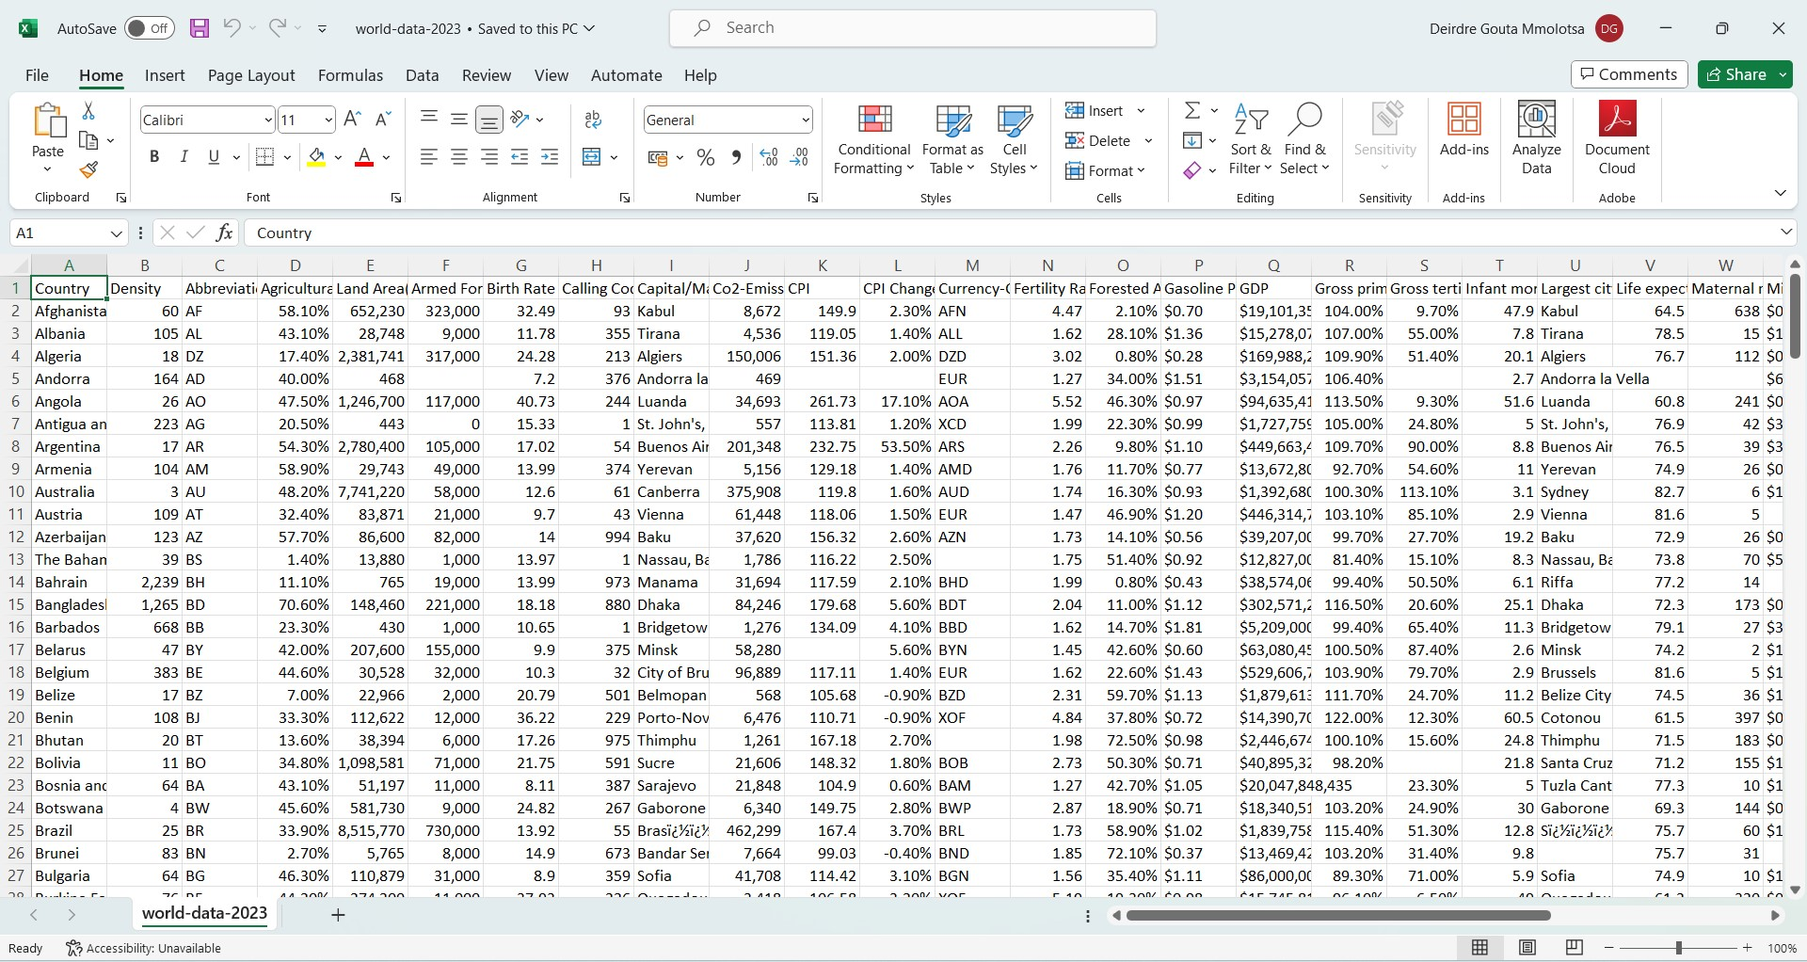

Figure . “world-data2023.csv” dataset

Figure 1 shows the raw dataset in Excel. It is structured and is comprised of numerical data. Initially, there are 36 attributes and 197 observations as well as several errors within the dataset. Some of the errors found include missing values, spelling errors, and unwanted common leading strings.

According to (Sharda, 2017), the second phase of data processing is data cleaning where values in the dataset are identified and dealt with. This includes imputation / ignoring where there are missing values, identifying, and smoothening out noisy values (reducing noise (i.e., outliers)), and eliminating duplicates. To address missing values error, empty cells were nullified as seen in Figure 2 below, and formatting was adjusted to keep the appearance of data within the cells consistent.

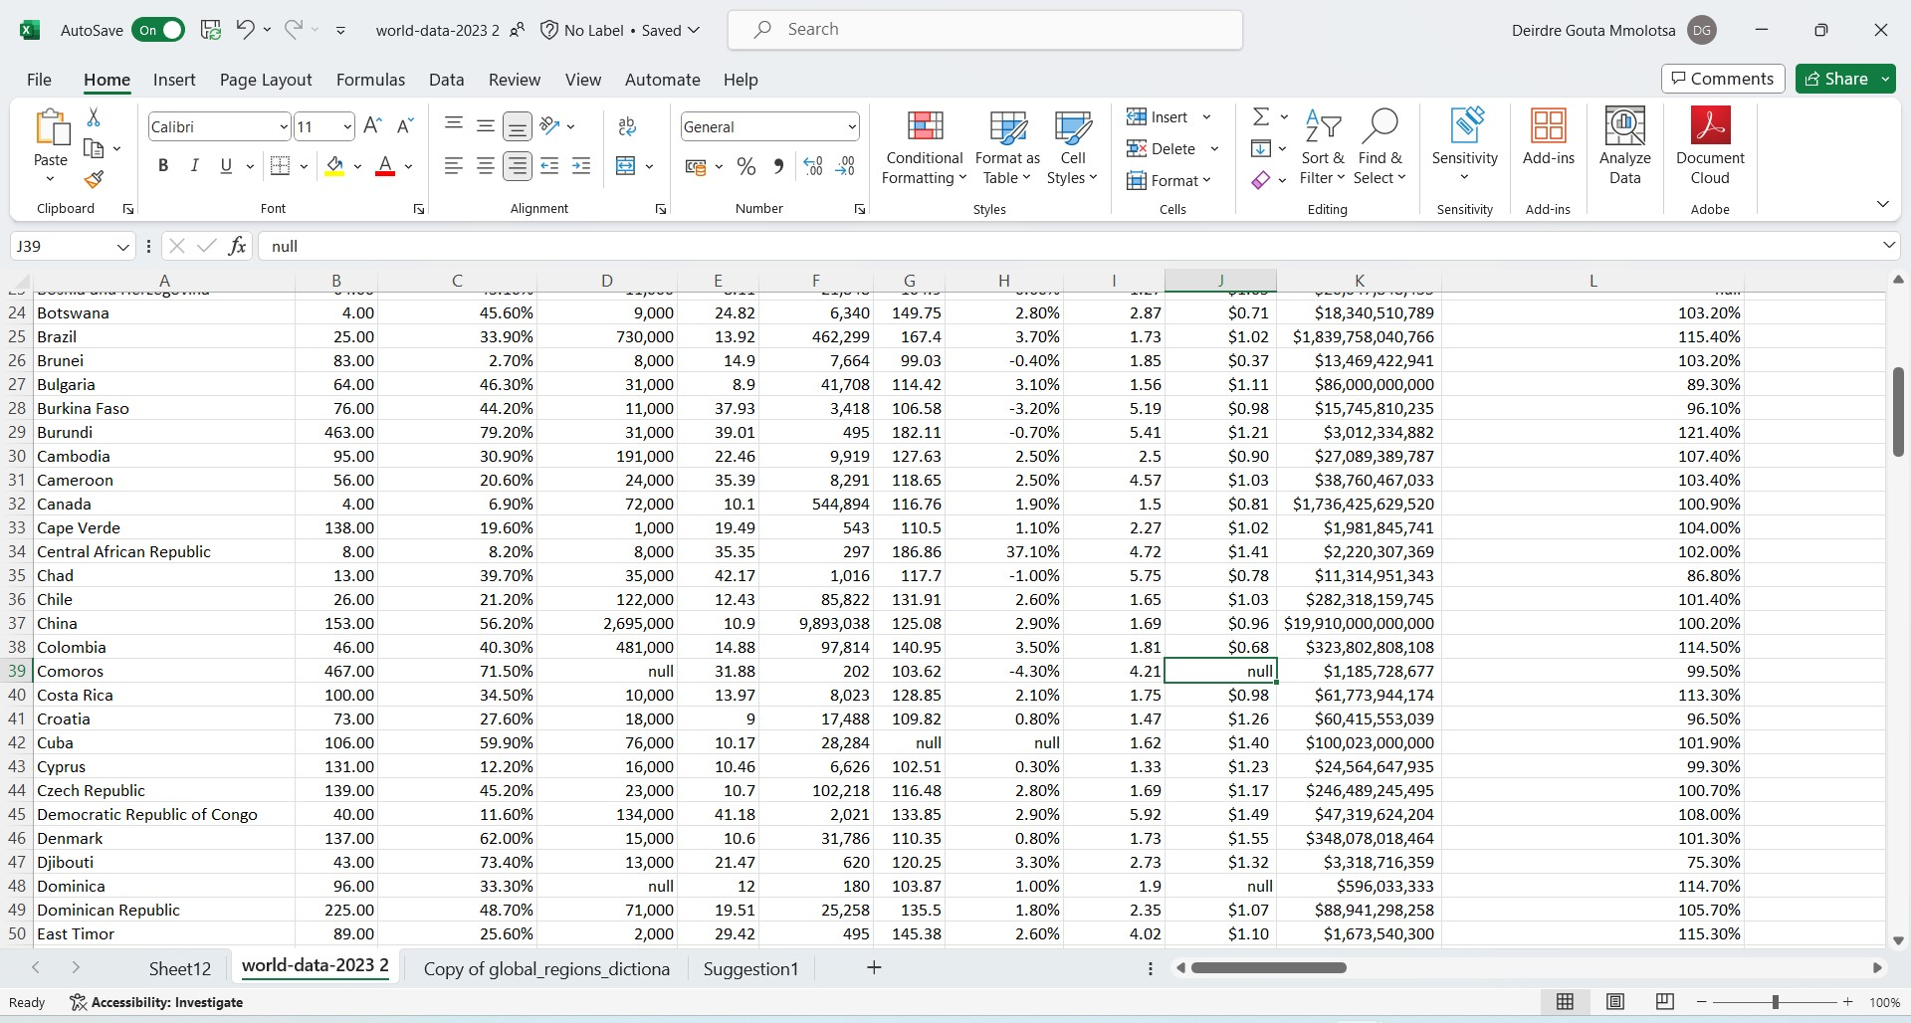

Figure . Errors in the raw dataset

Common leading strings were removed in column country by using the power query editor and modifying column functions. Select Data🡪Get Data from Table/Range (To open the power query editor)🡪 Add custom column 🡪Modify the function fx and the original country column was replaced with the new one. In addition to that, a summary of data cleaning steps from (support.microsoft.com(n.d), 2022-04-15) was followed when cleaning the “world-data2023.csv” dataset. In this case, variables (non-key variables) that do not influence international immigration/ emigration were removed. Deduplication of the dataset was checked by selecting conditional formatting🡪 highlight cell rules🡪 duplicate values.

Even though the dataset may look clean some underlying errors may affect the overall quality of the dataset. These may include incompleteness and inaccuracy of the data collected.

Poor quality of data such as inaccurate healthcare metrics contributes to poor decision-making and inefficient resource allocation and may threaten the validity of impact evaluations (Getachew, 2022). Miscalculations of other global metrics such as economic indicators may mislead policy-making decisions.

In terms of missing values, the Listwise or case deletion approach was used in the queried table containing the global regions, countries, and variables of interest to be analysed. This remedy is used to simply omit cases/observations with missing data and analyse the remaining.



Figure . Selected data for analysis

Figure 3 shows the exclusion of null values from the data to be analysed. The assumption of MCAR is satisfied because there is no relationship between missing data in the dataset and any other values observed or unobserved (data not recorded in the dataset) therefore the analysis of this data will produce unbiased estimates and conservative results (Kang, 2013).

The variables of interest in this report are population density, life expectancy, GDP, and minimum wage. Out of all these four, Life expectancy is the independent variable because the average number of years a person is expected to live is influenced by the independent variables: GDP (Gross Domestic Product), a standard measure of the total monetary value of value-added and created through the production of goods and services within a country during a certain period ((OECD), 2023). Minimum wage is the lowest legal amount of remuneration that an employer is required to pay wage earners for the work within a given period (Placeholder1). This variable affects/influences wage policies and socio-economic factors which potentially affect life expectancy. Finally, Population density is the number of people living per unit area (per square kilometer or mile). Changes in this global metric can cause changes in policymaking in terms of catering for rising/ declining numbers in population in healthcare, social services, and efficient utilization of economic resources. Therefore, Life expectancy is observed or measured in response to changes in various factors including those mentioned.

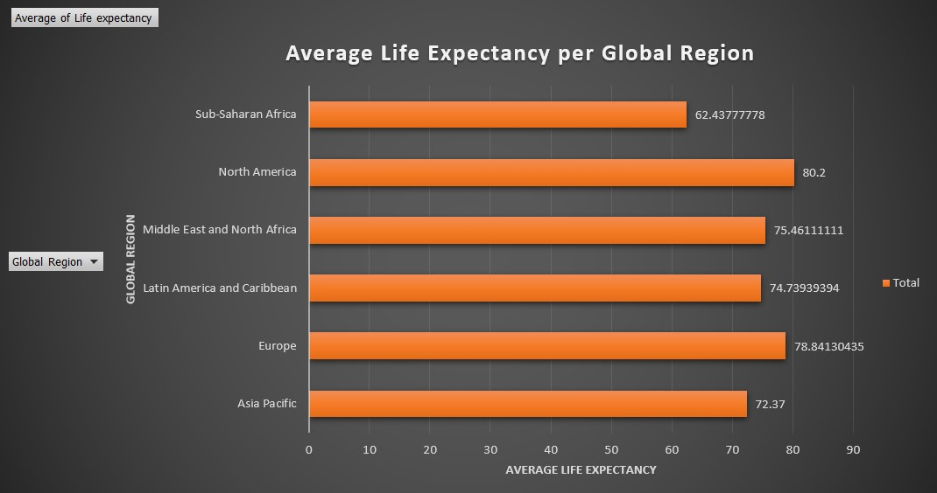

Figure . Horizontal bar chart measuring Average life expectancy per global region.

The stats on average life expectancies for different global regions have been measured using a horizontal bar graph in Figure 4.

Sub-Saharan Africa has been categorized by a lower average life expectancy of 62.44 compared to the other regions. Potential contributors could include healthcare challenges and economic disparities. This underscores the need for targeted healthcare interventions, economic development policies, and international aid to address factors that shorten the life expectancy of people in the region. North America has a relatively high life expectancy of 80.2. The assumption is that there is better socio-economic stability and overall quality of life thus having an impact on life expectancy.

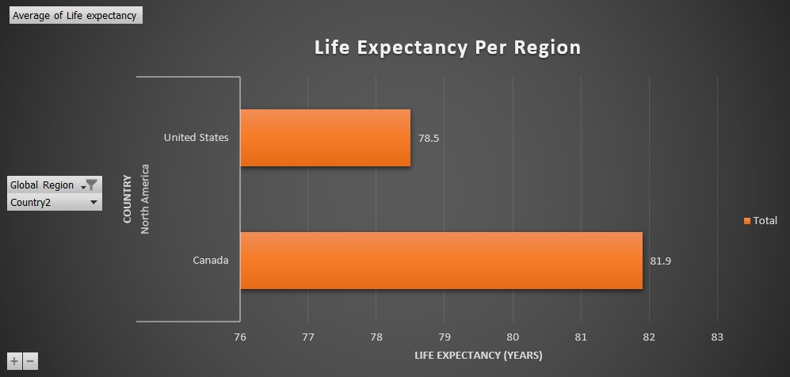

Figure . Horizontal bar chart comparing life expectancies of two regions in North America.

When zooming in on North America, one could consider living in the countries illustrated in Figure 5 if they are considering moving to a place where there is a high average life expectancy.

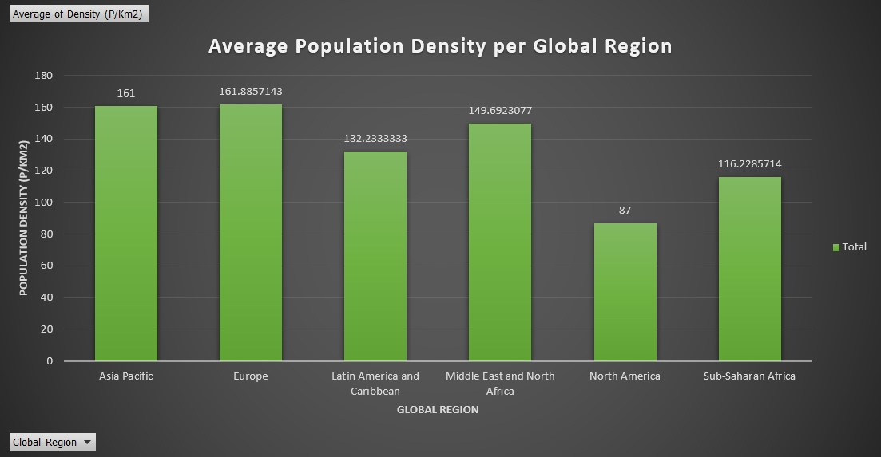

Figure . Horizontal bar chart showing Average population Density per Global Region

Even though there is a high average life expectancy in North America, the average population of inhabitants is quite low. Therefore, Immigration/ emigration policies can be implemented to attract individuals seeking a high quality of life.

Middle East and North Africa Latin America and the Caribbean have a moderate life expectancy which suggests economic inequality. Socio-economic policies that focus on reducing disparity can enhance life expectancy. Europe has a relatively high life expectancy but there might be some variations between specific European countries. When looking at the average population, the assumption is that immigration/ emigration policies were implemented to attract individuals seeking stable and developed societies.

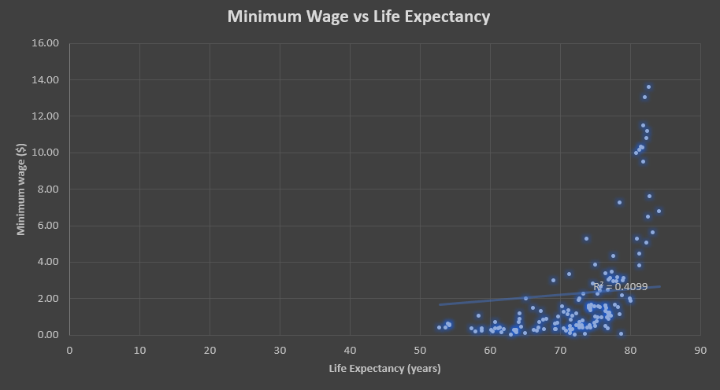

Figure . Minimum wage vs Life Expectancy scatter graph

The scattered points indicate a range of minimum wage values from 0.00$ to 14.00$ as well as corresponding life expectancies spanning from approximately 50 to 85 years. This wide dispersion illustrated in Figure 7 suggests that factors beyond minimum wage play a crucial role in influencing life expectancy. A regression line was added to measure the relationship between the two variables. The conclusion is that there is a positive correlation between the two variables, and R-squared = 0.4099 shows a moderate relationship between higher minimum wages and increased life expectancy. While the correlation is statistically significant, the moderate R-squared value implies that only a portion of the variability in life expectancy can be explained by changes in minimum wage and other influential factors must be considered.

Another observation is that as minimum wage increases, there is a general trend towards higher life expectancies. An assumption that can be drawn from this is that to some extent, a higher minimum wage may contribute to improved living conditions. Comprehensive policies that focus on equitable wages might positively impact public health therefore they should be considered for implementation. The limitations of the R-squared value of 0.4099 indicates that there are unaccounted factors influencing life expectancy and further research is needed to identify and understand those factors. It is important to do so to ensure that within the process of making policy-making decisions, the relationship between minimum wage and life expectancy is not oversimplified and underestimated.

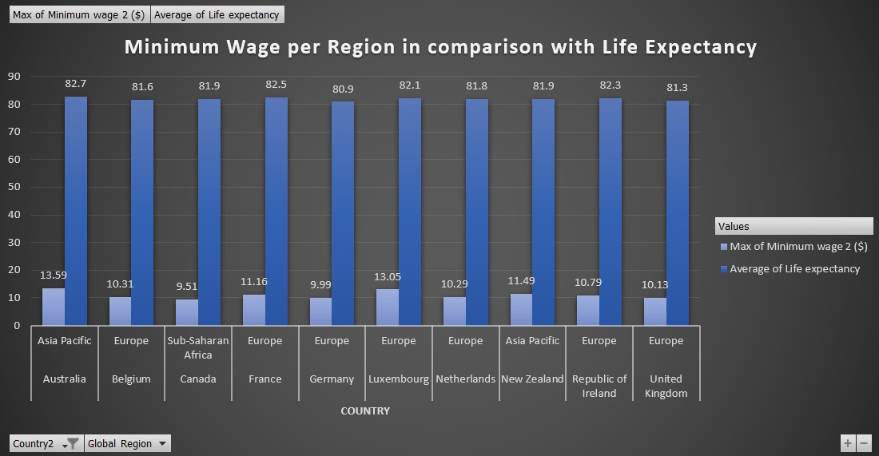

Figure . Clustered bar chart showing a close-up of minimum wage vs life expectancy

Figure 8 zooms in on a selection of the top 10 countries in their respective regions and compares their minimum wages and life expectancies.

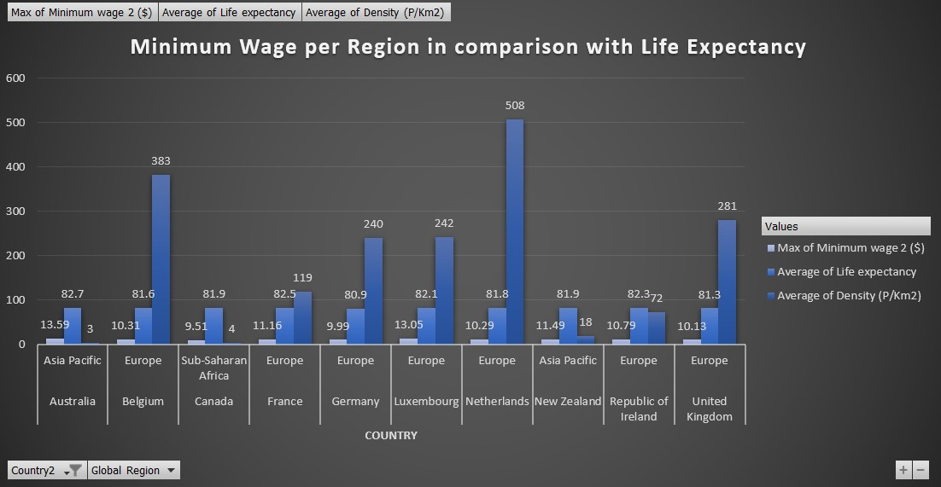

Figure . A clustered chart showing the 3 global metrics analysed thus far.

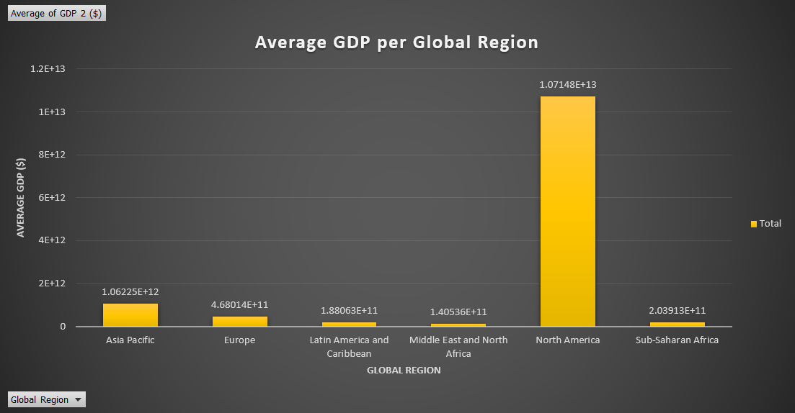

Figure . Bar chart showing Average GDP per Global Region.

The bar chart above illustrates the average GDP per global region, providing insights into the economic performance of each region. North America stands out with the highest average GDP, a substantial figure of 1.07148E+13, reflecting the economic strength and dominance of this region on the global scale, Asia Pacific follows closely with a significant average GDP of 1.06225E+12 and Europe with a substantial average GDP of 4.60014E+11 highlighting their economic significance and stability. The other regions have relatively lower but still notable average GDPs. Policymakers can utilize this information to address disparities among regions and investors seeking opportunities in different parts of the world can use this metric.

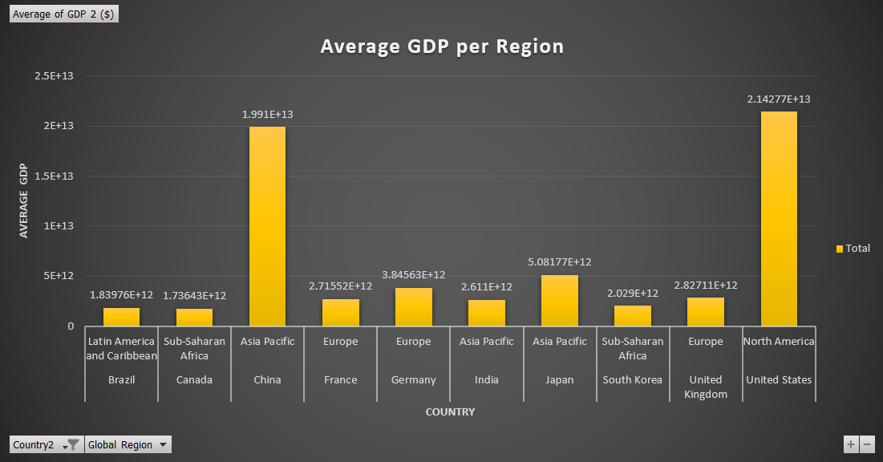

Figure . Bar chart showing Average GDP per region (zooming in on top 10 countries)

With the highest average GDP in North America, the United States is a global economic leader. Its economic strength impacts not only the region but has ripple effects across the world. In the expansive region of Asia Pacific, the economic landscape is marked by the influential presence of China. As the second-largest economy globally, China’s robust economic growth resonates within its region, shaping both regional and global economic trends.

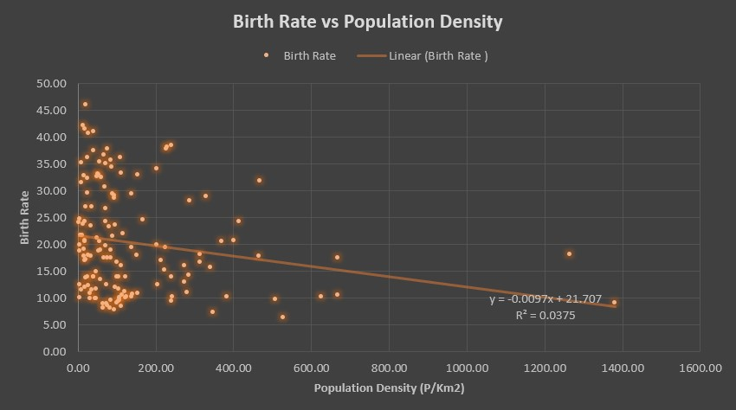

Figure . Scatter graph showing the relationship between birth rate and population density

From Figure 12, the equation y = -0.0097x + 21.707, suggests a negative correlation between birth rates suggests a negative correlation between birth rate and population density. The R-squared value of 0.0375 shows that the model doesn’t explain a large proportion of variance in the data, thus suggesting a weak correlation. Birth rate points are heavily scattered between 0.00p/km2 and 200.00p/km2 and sparsely scattered after 200p/km2. This could mean that up to a certain population density, there might be other factors influencing birth rates but beyond that threshold, they may become more influential.

The two birthrate points between 1200.00p/km2 and 1400.00p/km2 could be outliers. Given the information above, the outliers identified were identified from the sample data used for this analysis as seen in figure 10 and 11 below.



Figure . Finding outliers

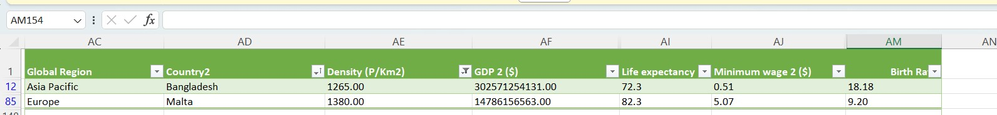

Figure . Outliers identified

Investigating these outliers might provide insights into unique social, economic, or environmental factors that affect birthrates in highly populated areas.

To have a more nuanced understanding of the factors influencing high birth rates, “Gross tertiary education enrolment %” seemed to be a suitable variable to explore in the context of investigating the relationship between high birth rates and population density.

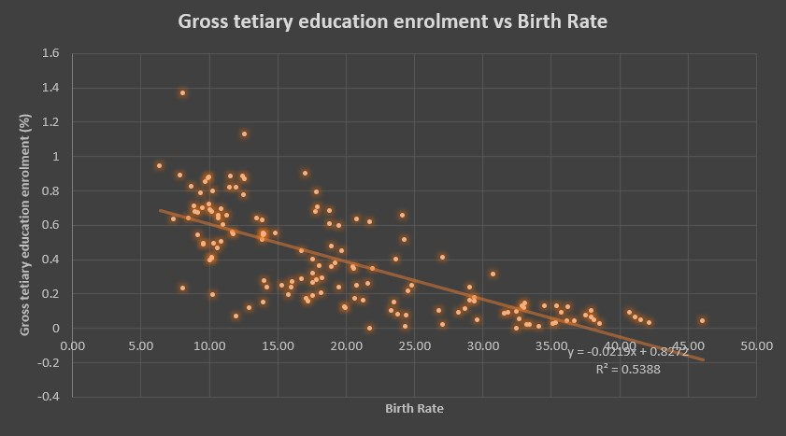

Figure . Scatter graph which shows the relationship between Gross tertiary education enrolment vs Birth Rate

Gross tertiary education environment seemed to be a more suitable variable to assess with birth rates because tertiary education refers to higher education. This level of education is often associated with a more mature age group and greater exposure to family planning information practices.

The equation provided in Figure 15, y = -0.0219x + 0.8272 suggests a negative correlation between the two variables and R-squared value = 0.5388 indicates that the model explains a significant portion of the variance in the data, suggesting a moderate to strong correlation. Looking at the distribution of scatter points, at lower levels of tertiary education enrolment, there is a more pronounced impact on birth rates. This metric was further analysed to have a better understanding of what the descriptive statistical results show.

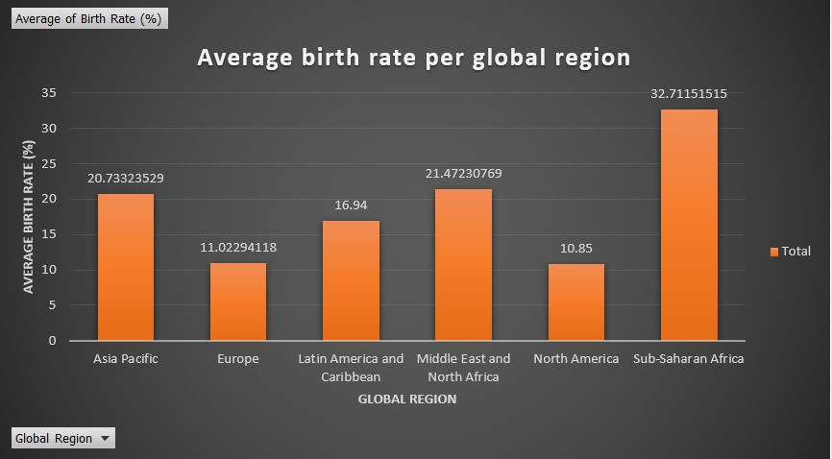

Figure . Bar chart showing the average birth rates of each global region.

Figure 16 visually represents the average birth rate percentage for each global region. Sub-Saharan Africa has the highest average birth rate at 32.7115% indicating a high average number of births per 1000 people, while North America has the lowest at 10.85% and Europe closely at 11.0229%. These two regions have comparatively lower average birth rates. The other regions fall in between.

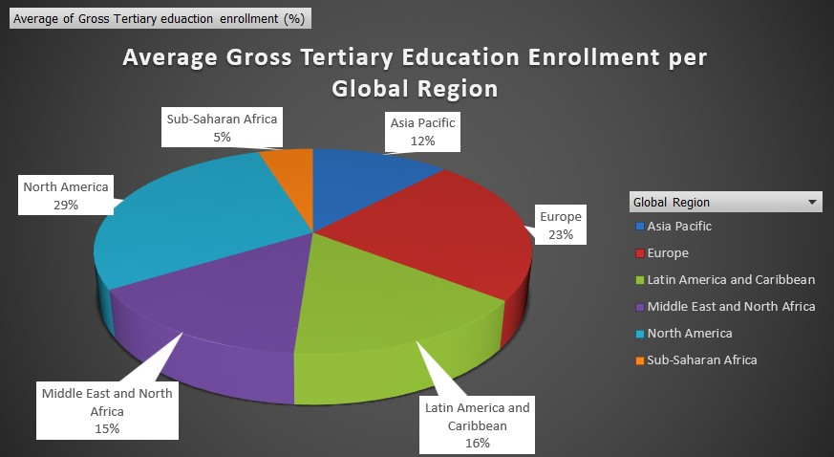

Figure . Pie chart showing the average gross tertiary enrolment for each region.

The pie chart visually represents the distribution of average gross tertiary enrolment percentages for each global region. Sub-Saharan Africa has the lowest at 5% and the highest being North America with 29% followed by Europe with 23%. The other regions fall in between the second highest and lowest average percentages.

From Figure 16 and Figure 17, the observation is that North America, with the lowest birth rate, has the highest average gross tertiary enrolment, and Sub-Saharan Africa with the highest birth rate, has the lowest average gross tertiary enrolment. There seems to be an inverse relationship between birth rates and tertiary education enrolment at a regional level.

The trend seen here is that regions with higher average gross tertiary enrolment (North America and Europe) tend to have lower birth rates and Sub-Saharan Africa with the lowest tertiary enrolment has the highest birth rate.

The high birth rates in Sub-Saharan Africa in the chart align with the scatter graph in Figure 15 ’s suggestion of a weak negative correlation with population density. However, Figure 17 ’s emphasis on lower tertiary education enrolment in Sub-Saharan Africa aligns with the idea that education might play a role in understanding birth rate variations, as indicated in the scatter graph analysis. Higher education enrolment percentages in North America and Europe in the pie chart align with these having lower birth rates, suggesting a potential association between education and birth rate trends.

Moreover, the bar chart and pie charts provide context to the scatter graph by introducing regional variations in birth rates and tertiary education enrolment. This is to enhance our understanding of the complex relationships between birth rates, population density, and education.

In terms of socioeconomic and environmental implications, high birth rates could strain resources, leading to challenges in providing adequate healthcare, education, and employment opportunities (Tutorchase.com, 2022). On the environmental front, high population density can lead to increased pollution, deforestation caused by an increase in infrastructural developments to accommodate people and other environmental degradation. The analysis of tertiary education enrolment suggests that education may be a key factor influencing birth rates, highlighting the potential for social and economic development through education.

Governments and policymakers may need to formulate strategies to manage population growth, ensure equitable distribution of resources, and implement sustainable development practices. Policy makers could focus on initiatives to address high birth rates such as family planning programs and recognizing the impact of education on family planning decisions. According to (Cleland, 2006) promotion of family planning in countries with high birth rates has the potential to reduce poverty and hunger and avert 32% of all maternal deaths. It contributes to economic development by allowing families to plan and invest in their children’s education and well-being because spacing and limiting births can positively impact family finances and reduce the strain on resources. Therefore, sustainable development policies may aim to balance population growth with environmental sustainability and resource management. Policies promoting maternal health, access to contraception, and economic opportunities for women to be crucial in addressing high birth rates can also be considered for implementation.

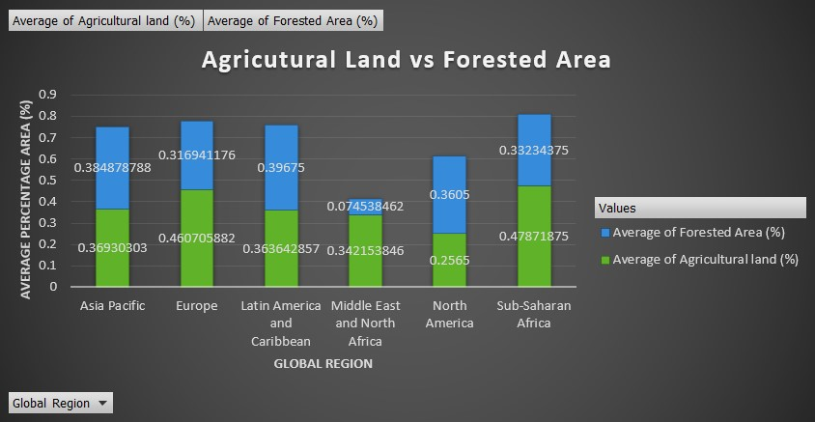

Figure . Stacked column chart showing Average agricultural land vs Forested area.

Asia Pacific has similar percentages for agricultural land and forested areas as seen in Figure 18, indicating a balanced distribution of land usage. Europe has a higher percentage of agricultural land compared to forested areas. There is a balanced distribution with a slightly higher percentage for forested areas in Latin America and the Caribbean. North America has a lower percentage of agriculture with a balanced distribution between agricultural land and forested areas. In the Middle East and North Africa, agricultural land is dominant with a significantly lower percentage of forested area and a predominance of agricultural land in Sub-Saharan Africa.

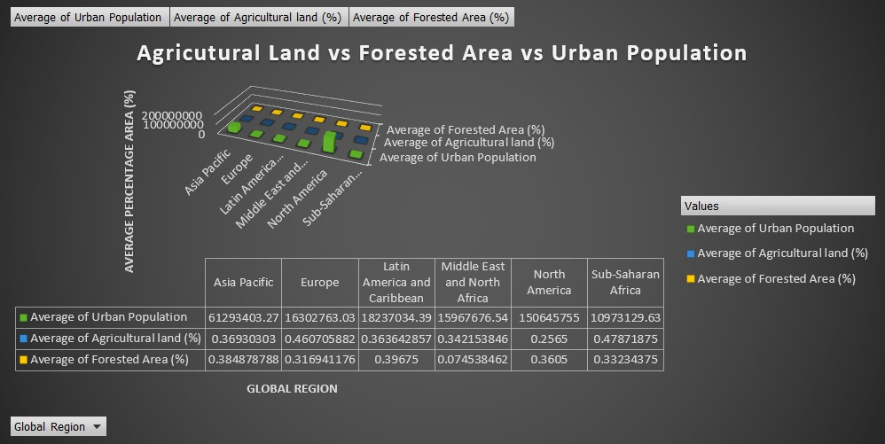

Figure . 3D clustered bar chat

Figure 19 simply shows the values of the urban population and how they relate to land distribution. In Asia Pacific, a high population may necessitate effective urban planning for infrastructure and resource management, and a moderate urban population with potential implications in Europe. Similar considerations for urban planning, balancing population density and resources are implications of urban populations in Latin America and the Caribbean. Sub-Saharan Africa has a low urban population, indicating potential for urban development but requiring strategic planning.

Land distribution for agricultural purposes directly influences a nation’s food security. Countries that have a high proportion of agricultural practices must be considered to ensure long-term food security. Regions that experience rapid urbanization however require careful planning when it comes to infrastructure needs, housing, and resource distribution. This is because it is important to balance urban growth and environmental conversation to create sustainable living environments. The distribution of forested areas plays a critical role in environmental conservation however, regions with high forest area contribute to biodiversity preservation, reduced carbon in the atmosphere, and overall ecosystem health.

As seen in Figure 18, Sub-Saharan Africa has the highest percentage of agricultural land compared to other regions. This could suggest potential challenges and opportunities that require holistic consideration in policy-making and planning. The World Bank has a land governance assessment framework (Deininger, 2012) that guides policymakers willing to address land distribution. The Bank supports and consistently advocates for government policies that endorse comprehensive land surveying and tilting initiatives. These programs are designed to acknowledge the diverse forms of land tenure, encompassing both public and private ownership, formal and customary arrangements, including those of pastoralists or individuals with less pronounced formal rights. The approach extends to recognizing both collective and individual land rights, with a specific emphasis on ensuring the rights of women. This inclusive approach spans rural and urban areas, aligning with the Bank’s commitment to fostering equitable land policies worldwide.

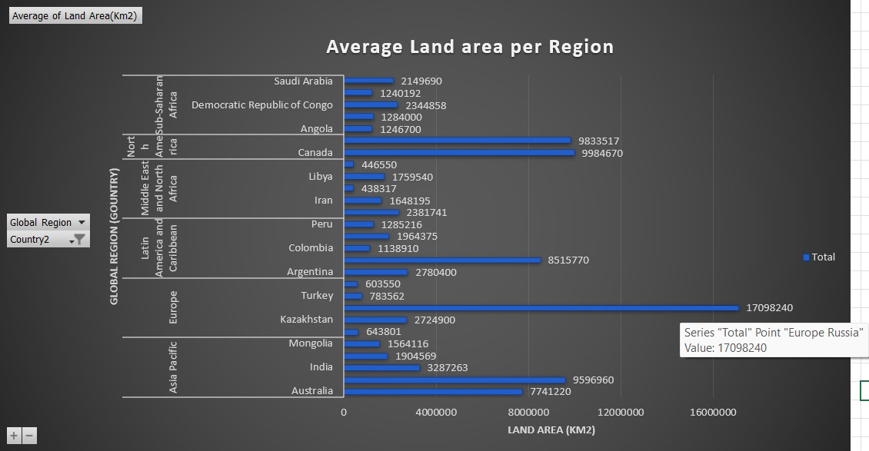

Figure . horizontal bar chart which shows the average land areas of different regions.

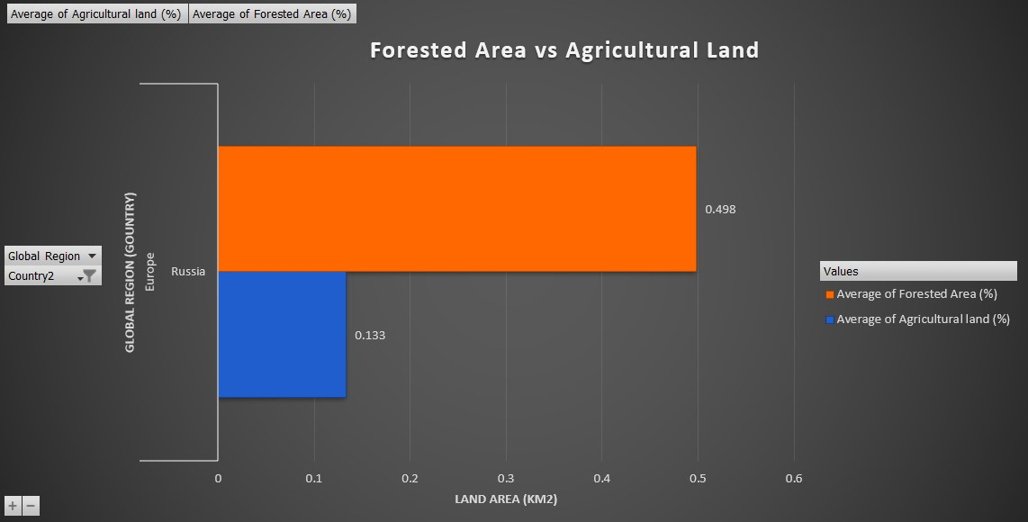

Figure . Zooming into “Russia” which has the highest land area, by measuring land distribution between Forested areas and Agricultural land.

Despite having a significant land area, Russia doesn’t predominantly use it for agriculture as illustrated in Figure 20 and Figure 21. This can be attributed to several factors such as Diverse Geography, since Russia’s vast land encompasses diverse geographic features and extremely cold and harsh climates, of which some may be unsuitable for intensive agricultural practices and can limit the types of crops that can be cultivated. However, Russia might prioritize other factors such as energy, mining, or forestry where it has abundant natural resources therefore shifting its economic priorities and land use policies over time.

Investors navigating through complex global landscapes of financial decisions should highly prioritize key metrics that offer profound insights into economic dynamics. The first metric is Gross Domestic Product (GDP) which is a compass for investors, pointing to profitability and the well-being of citizens. Globally, GDP is a cornerstone influencing trade pacts and fostering stability in the interconnected economic web. It influences international economic cooperation and trade agreements which contribute to the stability of the global economic stage.

Consumer Price Index (CPI) is about understanding how inflation influences the marketplace. It reflects the flow of the cost of living. Investors who adapt their strategies based on CPI insights, play a role in shaping policies that manage inflation domestically and globally. However, this guides nations in the aspect of managing inflation and maintaining economic equilibrium.

Minimum wage (income and wages) is another compelling metric of importance for investors which tells stories of economic well-being, labor market conditions, and societal trends. When investors make decisions based on these metrics, they therefore influence policies related to fair wages, social welfare, and the pursuit of inclusive economic growth.

Investors should consider population density because it impacts demand for goods and services, affecting market potential. A high population density can represent a larger consumer base, while a low density may indicate untapped markets. Countries with high population density may influence policies related to resource management, urbanization, and international collaborations may focus on addressing challenges caused by this metric.

Another global metric that investors should take into consideration is the unemployment rate. This is because it reflects the health of the labor market within a country. The unemployment rate represents the percentage of the labor force that is unemployed or is actively seeking employment. However, by closely monitoring this metric, an investor will acknowledge the impact embedded in economic challenges because it signals potential economic challenges and poses risks and threats for businesses. High employment rates may lead to policy initiatives focused on job creation and skills development and help in making informed decisions that also contribute to discussions on policy interventions for job creation and economic resilience.

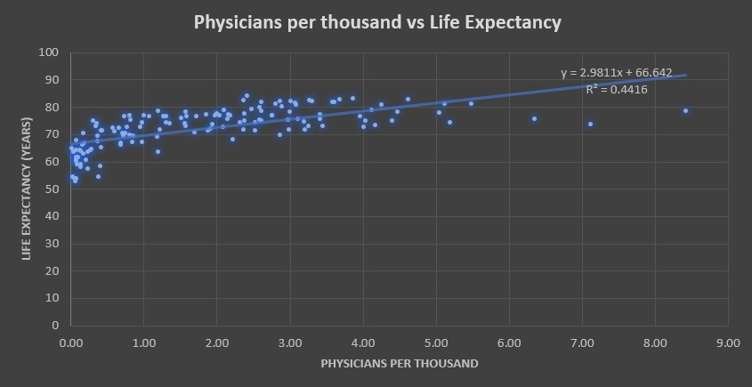

Figure . Scatter graph showing the correlation between physicians per thousand and life expectancy.

The trend line y = 2.9811x + 66.642 and R-Square value of 0.4416 shown in Figure 22 suggests a moderate positive correlation between the number of physicians per thousand people in a country and life expectancy. The positive slope of the trend line indicates that as the number of physicians per thousand increases, life expectancy steadily increases. The R-squared suggests that approximately 44.16% of the variability in the expectancy can be explained by the number of physicians per thousand. Potential reasons behind the observed correlation could be access to healthcare, Health Education, and economic development including other factors. Countries that have a higher density of physicians may provide better access to healthcare services and may invest more in health education and public health campaigns, promoting healthier lifestyles and reducing the prevalence, therefore positively impacting life expectancy. More physicians suggest that more manpower under healthcare services to tend to the public’s health needs.

According to (Biswal, 2023), Hypothesis testing is used to estimate the relationship between two statistical values. An analyst performs hypothesis testing on a statistical sample to present evidence of the plausibility of the null hypothesis. The difference between a z-test and a t-test is that a z-test is a type of hypothesis test that is used if the population standard deviation is known while a t-test is a type of hypothesis test that is used when the population standard deviation is unknown and must be estimated from the sample data, or when sample sizes are small.

Here is an example of how hypothesis testing was implemented.



Figure

In this case, even though there is a directional hypothesis indicated in Figure 22, a two-tale test (non-directional hypothesis; having a relationship in general and not about whether the relationship is negative or positive) is also done for statistical analysis. The one-tale test justifies this non-directional hypothesis. Figure 23 shows the Null hypothesis (there is no relationship), whatever one may think is incorrect and the Alternate hypothesis is that there is a relationship and Pearson’s r does not equal 0 (it's statistically different from 0).

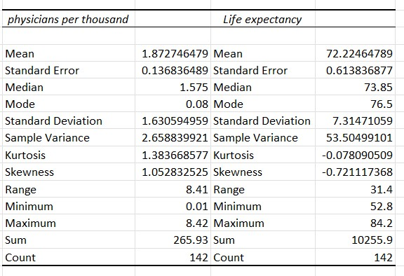

Figure . summary statistics of the two columns selected.



Figure . Testing Analysis summary output

The p-value that goes with the t-statistic test to see whether the r value is different from 0 or not. The two-tale p-value shown in Figure 25 is used to determine statistical significance. Significance tests are important because they extend to the robustness of research findings. Statistical significance provides a measure of confidence in the results, indicating whether the observed effects are likely to be genuine or merely due to chance. However, this information can be used to guide policymakers in decision-making since they’ll be relying on data-driven thoughts. Understanding the nuances of different statistical tests is important because if z-tests are applied when assumptions aren’t met, or t-tests are used with large samples and known population standard deviation inaccurate results will be produced. Hence, compromising findings and misleading policy makers in critical decision making.

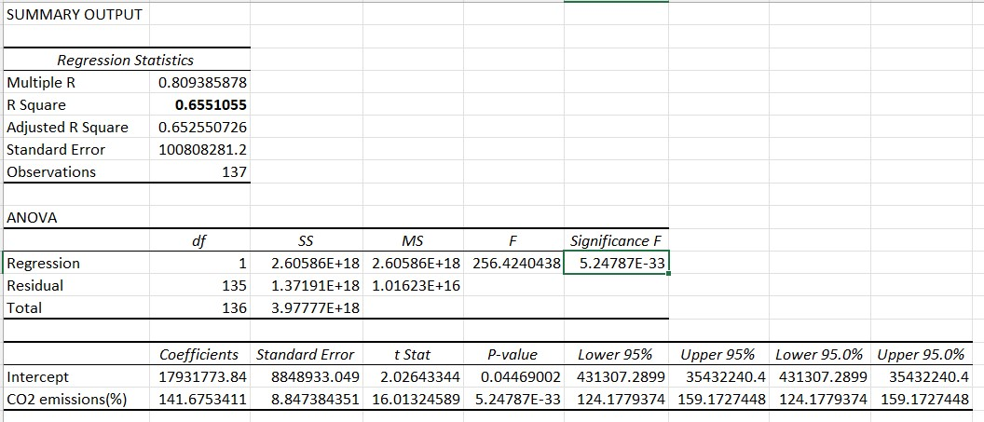

Figure . Regression analysis model

Figure 26 shows the regression analysis conducted on the relationship between country population and CO2 emissions which reveals a statistically significant and positive correlation. Multiple R is a correlation coefficient of 0.809 which indicates a strong positive correlation between population and CO2 emissions. The R- square value of 0.655 is a coefficient of determination which implies that about 66% of the variability in CO2 emissions can be explained by changes in population. These coefficients indicate that, on average, for every percentage increase in CO2 emissions, there is an associated increase of approximately 141.68 units in the dependent variable.

The statistical significance of the overall model, as indicated by the p-value of the F-statistic (256.42), strengthens the validity of the observed relationship. External factors such as industrialization, economic development, and energy resources may influence this correlation. People release carbon dioxide from their bodies, urbanization to accommodate people (removing trees (which photosynthesize to reduce carbon dioxide) and clearing of land to build homes, workplaces, restaurants, etc), and the use of machines in industrialization all contribute to the increase of CO2 emissions. Policy recommendations could focus on promoting green technologies, considering population control policies, and investing in renewable energy sources to address the impact of growth on CO2 emissions. However, policy decisions must be approached with a comprehensive understanding of the complex interpretation of socio-economic and environmental factors.

# References

(OECD), O. f. E. C.-o. a. D., 2023. *Gross Domestic Product (Indicator).* [Online]   
Available at: doi: 10.1787/dc2f7aec-en  
[Accessed 23 October 2023].

Biswal, A., 2023. *Simplelearn.* [Online]   
Available at: https://www.simplilearn.com/tutorials/statistics-tutorial/hypothesis-testing-in-statistics  
[Accessed 08 November 2023].

Cleland, J. B. A. F. A. G. A. &. I. J., 2006. Family planning: the unfinished agenda. *The Lancet,* 368(9549), pp. 1810-1827.

David Booth, D. C., 2013. *Governance for Development in Africa.* s.l.:Zed Books Ltd.

Deininger, K. S. H. B. A., 2012. *The Land Governance Assessment Framework: Identifying and Monitoring Good Practice in the Land Sector.,* s.l.: © World Bank..

Getachew, N., 2022. Data quality and associated factors in the health management information system at health centers in Shashogo district, Hadiya zone, southern Ethiopia, 2021. *BMC Medical Informatatics and Decision Making.*

Kang, H., 2013. The prevention and handling of the missing data. *Korean Journal of Anesthesiology,* 64(5), pp. 402-6.

Sharda, R. D. D. a. T. E., 2017. *Business Intelligence, analytics and Dara Science: A Managerial Approach.* 4th ed. Boston: Pearson Education,Inc.

support.microsoft.com(n.d), 2022-04-15. *Top ten ways to clean your data.* [Online]   
Available at: https://support.microsoft.com  
[Accessed Tuesday 10 October 2023].

Tutorchase.com, 2022. *Tutorchase.com.* [Online]   
Available at: https://www.tutorchase.com/notes/ib/ess/factors-influencing-population-growth  
[Accessed 30 October 2023].